CUSTOMER SHOPPING BEHAVIOR ANALYSIS

Business Intelligence and Customer Insights Report

Prepared By
Data Analyst

Tools Used
- Python (Pandas, NumPy)
- PostgreSQL
- SQL
- Power BI
- Gamma AI

1. Executive Summary
This project analyzes customer shopping behavior data to identify purchasing patterns, customer preferences, product performance, and revenue-driving segments.
The analysis combines Python for data preparation, PostgreSQL for business intelligence queries, and Power BI for interactive dashboard creation.
The objective is to convert raw customer transaction data into actionable business insights that support strategic decision-making.

2. Project Workflow
Raw Dataset
↓
Data Loading
↓
Data Cleaning
↓
Feature Engineering
↓
Exploratory Data Analysis
↓
PostgreSQL Analysis
↓
Power BI Dashboard
↓
Business Recommendations

3. Dataset Loading
The dataset was imported into Python using Pandas.

Screenshot 1: Dataset Preview
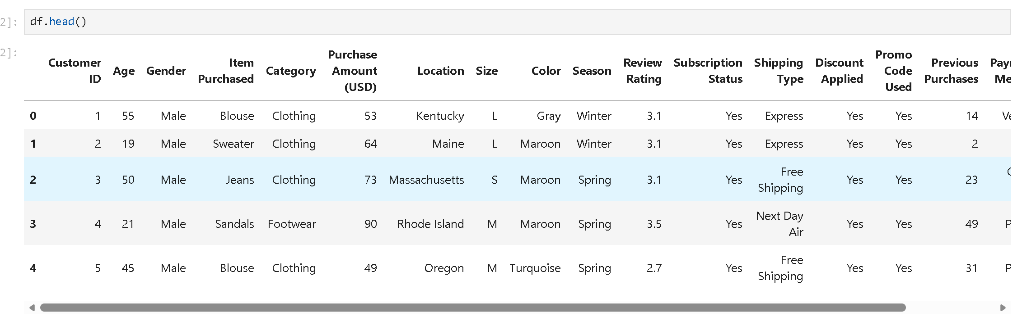

4. Data Understanding
Data inspection was performed using:
- df.info()
- df.describe()
- df.isnull().sum()

Screenshot 2: Dataset Information
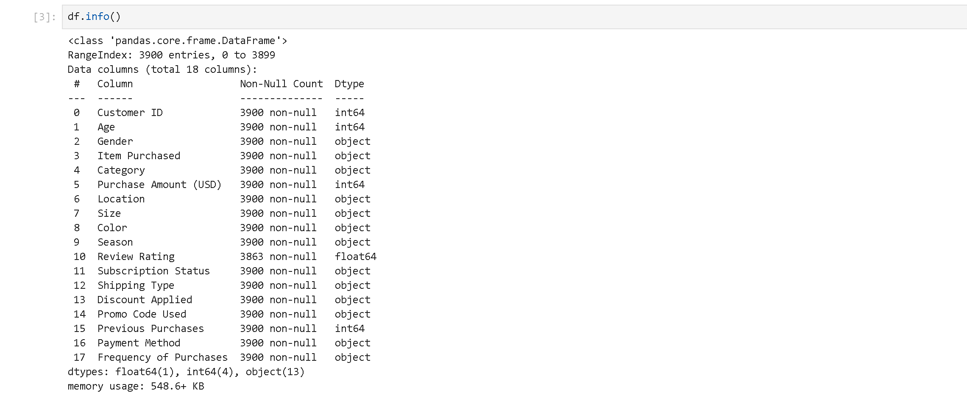

Screenshot 3: Missing Value Analysis
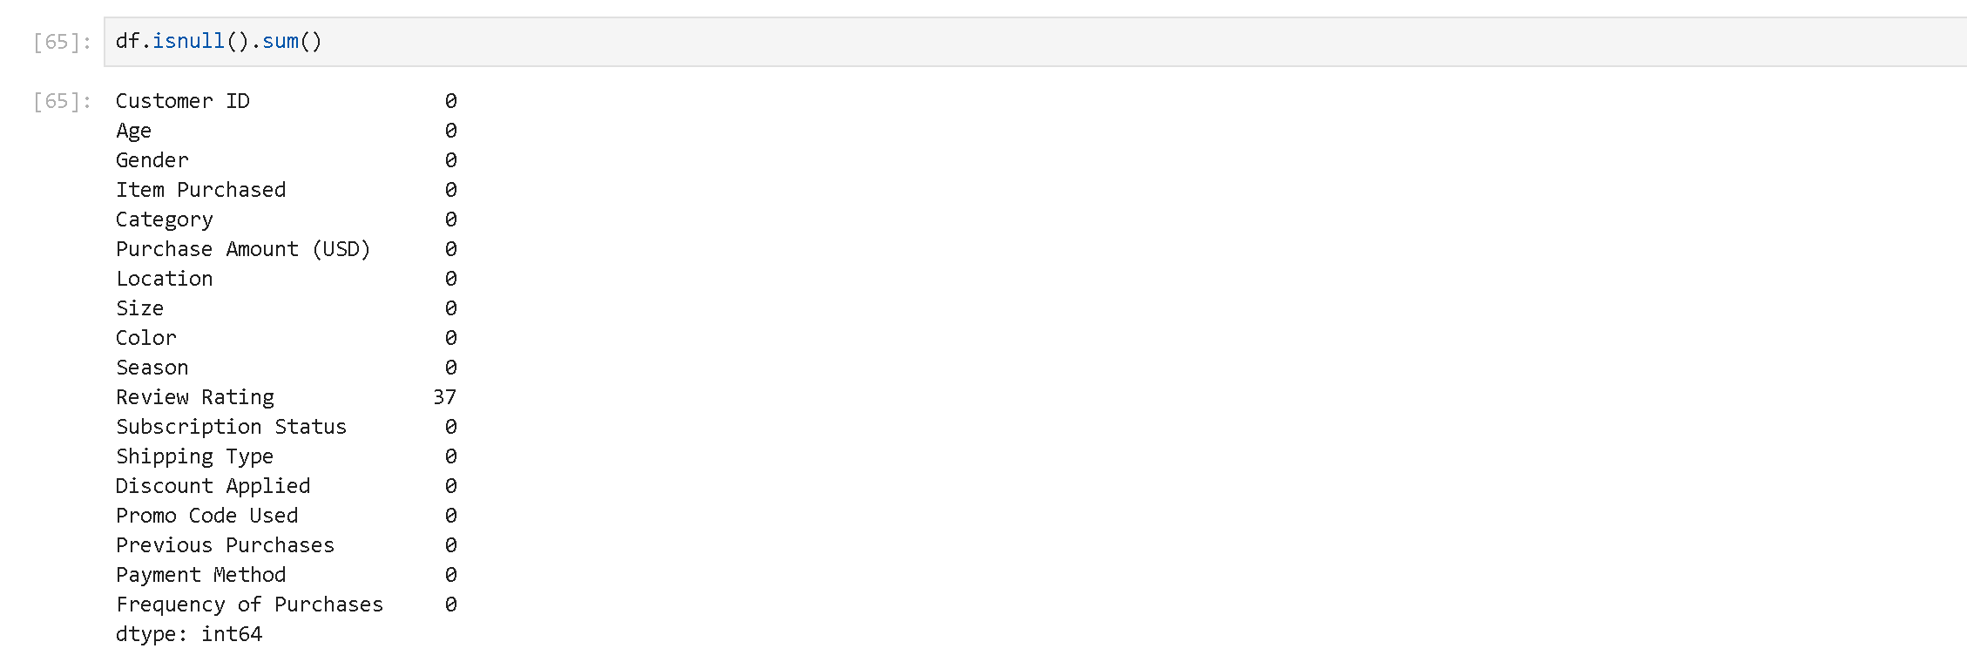

5. Data Cleaning
Several preprocessing steps were performed:

Activities Completed
✔ Missing review ratings handled
✔ Column names standardized
✔ Duplicate variables identified
✔ Irrelevant fields removed

Screenshot 4: Missing Values After Cleaning

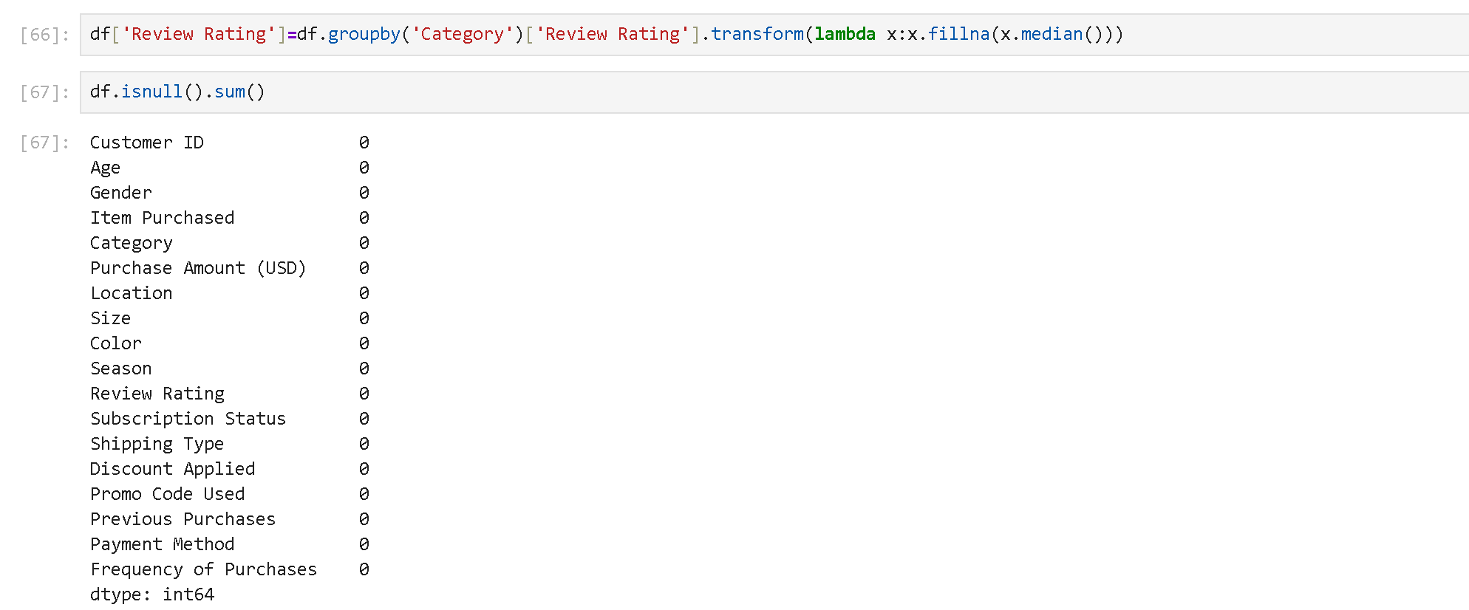

6. Feature Engineering
Additional business-focused variables were created.

Age Group Segmentation
Customers were grouped into:
- Young Adult
- Adult
- Middle-aged
- Senior

Screenshot 5: Age Group Creation
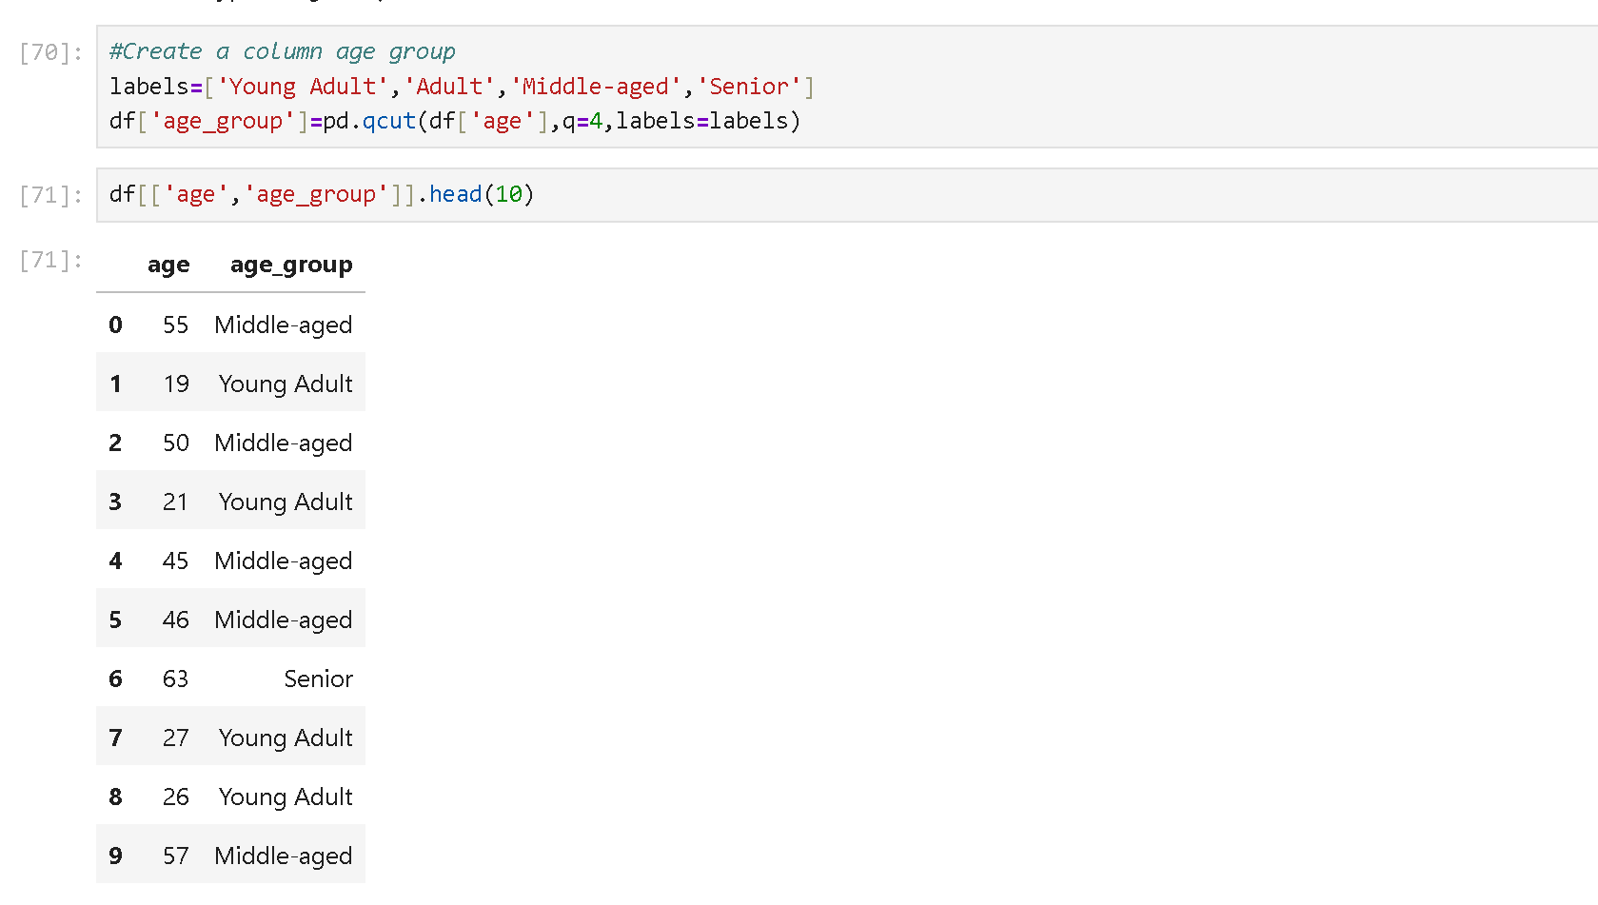

Purchase Frequency Transformation
Purchase frequencies were converted into numerical days.
Examples:
Frequency | Days
Weekly | 7
Monthly | 30
Quarterly | 90
Annually | 365

Screenshot 6: Purchase Frequency Days
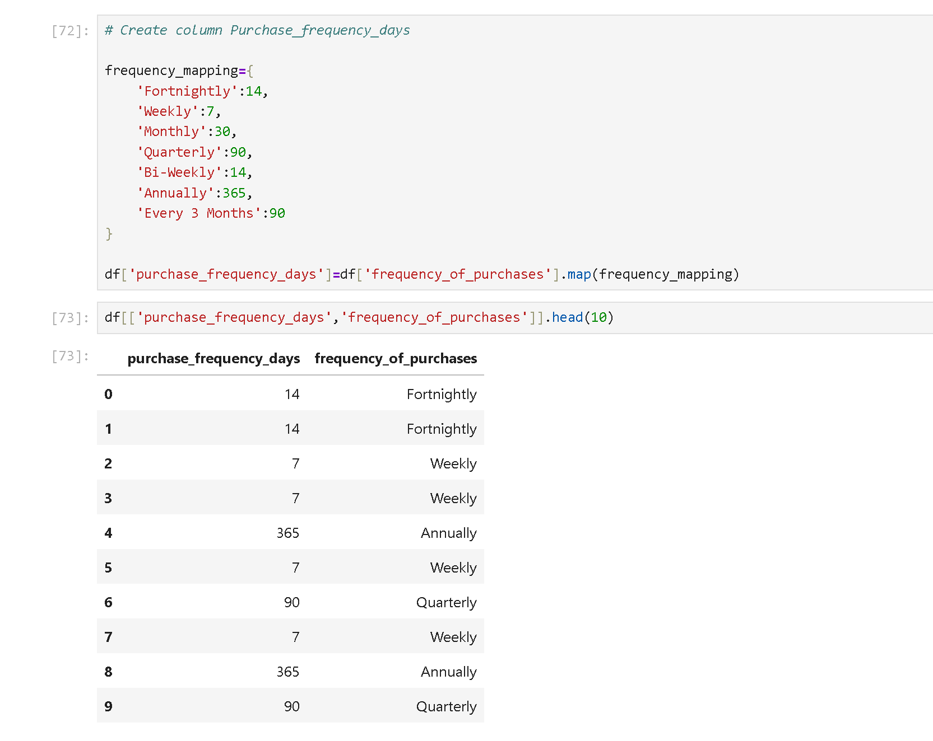

7. Data Validation
The project identified that:
- Discount Applied
- Promo Code Used
contained identical information.
The redundant field was removed.

Screenshot 7: Validation Check
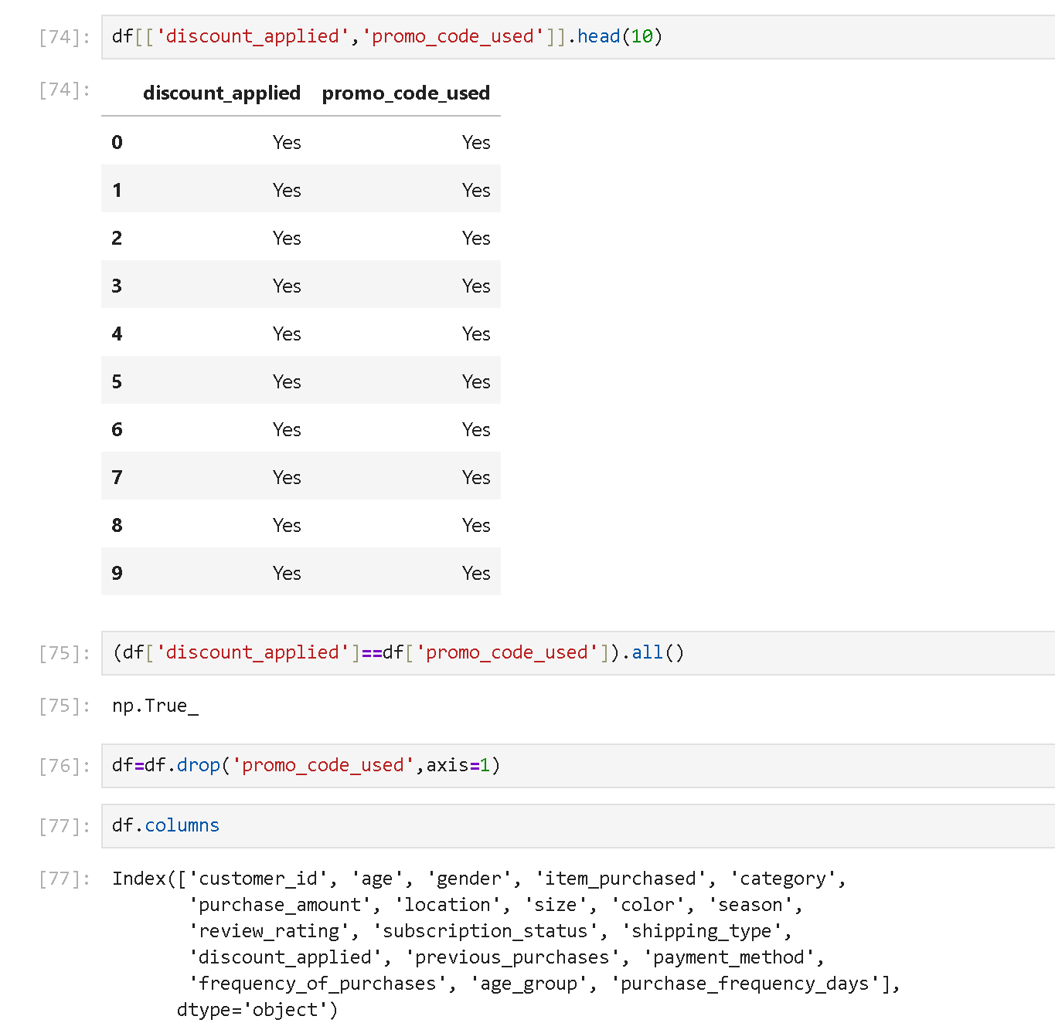

8. PostgreSQL Integration
After cleaning, the dataset was loaded into PostgreSQL for business analysis.

Screenshot 8: PostgreSQL Connection
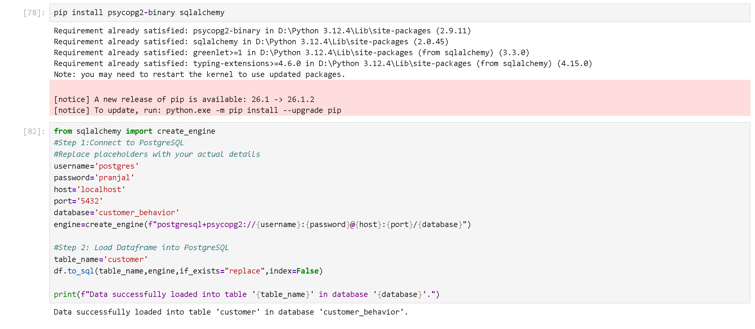

9. SQL Business Analysis

Revenue by Gender

Business Question
What is the total revenue generated by male and female customers?

Screenshot 9: SQL Query
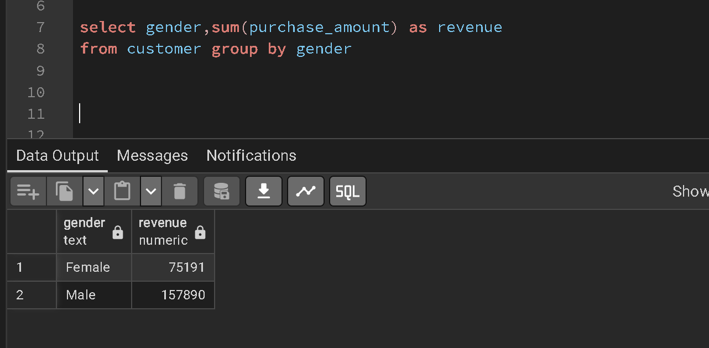

Business Insight
Male customers generated approximately twice the revenue compared to female customers.

Top Rated Products

Business Question
Which products have the highest customer ratings?

Screenshot 10: SQL Query
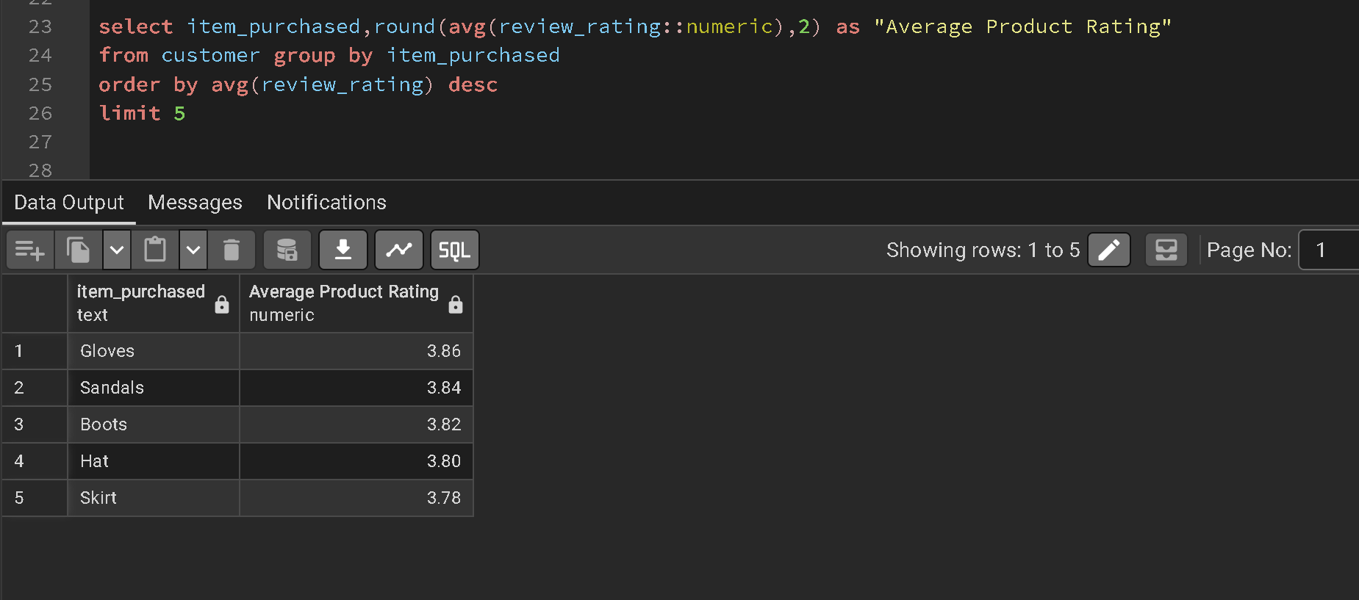

Business Insight
Gloves received the highest average customer rating and represent a strong-performing product category.

10. Power BI Dashboard

Dashboard Overview

Screenshot 11: Customer Behavior Dashboard
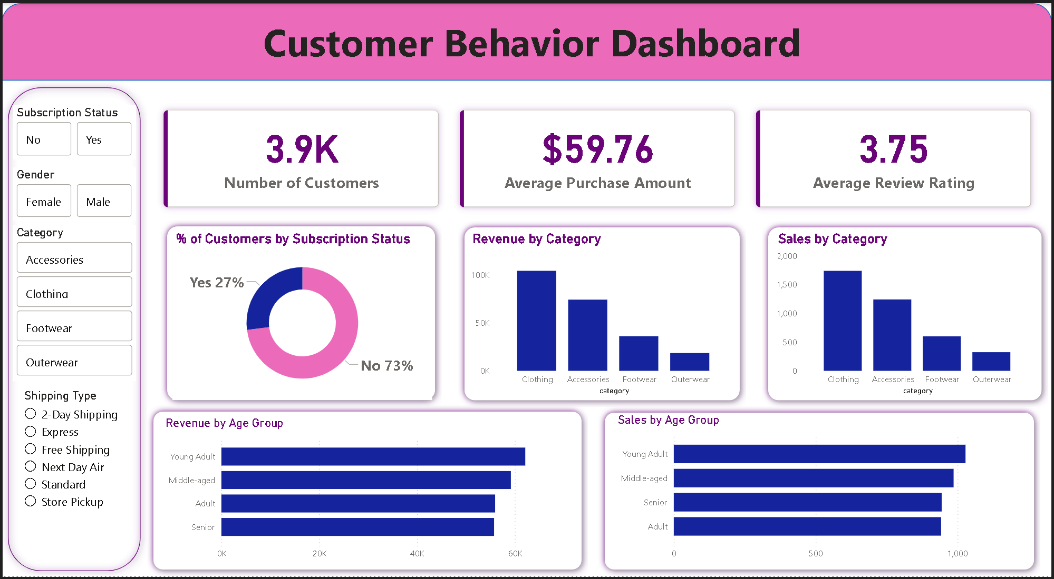
Caption: Interactive Power BI dashboard showing customer segmentation, revenue analysis, sales trends, and subscription behavior.

11. KPI Summary
KPI | Value
Total Customers | 1.737K
Average Purchase Amount | $60.03
Average Review Rating | 3.72

12. Dashboard Findings

Subscription Analysis
- Subscribed Customers: 26.31%
- Non-Subscribed Customers: 73.69%

Insight
A large portion of customers are not subscribed, indicating opportunities for loyalty programs and membership campaigns.

Revenue by Age Group
Young Adults generated the highest revenue.

Insight
Young Adults represent the most valuable customer segment.

Sales by Age Group
Young Adults also generated the highest sales volume.

Insight
Marketing campaigns should prioritize this demographic.

Category Analysis
Clothing generated the highest sales and revenue among filtered categories.

Insight
The Clothing category should remain a primary focus for promotions and inventory planning.

13. Key Findings
- Male customers generated significantly higher revenue.
- Young Adults are the highest-value customer segment.
- Clothing is a major revenue contributor.
- Subscription adoption remains low.
- Gloves received the highest customer satisfaction rating.

14. Business Recommendations

Increase Subscription Adoption
- Loyalty rewards
- Exclusive discounts
- Membership benefits

Focus on Young Adults
- Personalized promotions
- Social media campaigns
- Product recommendations

Promote Top-Rated Products
- Featured listings
- Bundled offers
- Upselling opportunities

Improve Customer Retention
- Reward repeat customers
- Introduce referral programs
- Enhance customer engagement

15. Conclusion
This project demonstrates a complete data analytics workflow using Python, PostgreSQL, SQL, and Power BI.
The analysis transformed raw customer shopping data into meaningful business insights, helping identify revenue drivers, customer preferences, and growth opportunities. The resulting dashboard enables stakeholders to make informed decisions regarding customer engagement, product strategy, and business performance.

